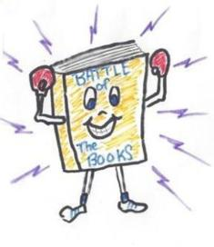**Battle of the Books Selection Process**

We were excited to see that so many students are interested in participating in the Battle of the Books. However, each school is only allowed to have three teams composed of no more than five students. We are looking to build three quality teams to compete in April. Since we have more than 15 students who wish to be on a team, our selection criteria will be as follows:

1. We will look at the number of Sunshine State Young Reader Award (SSYRA) books read by Friday, **February 14th**.
2. We will also consider the percentage correct based on AR scores.
3. Citizenship and sportsmanship are other considerations. Citizenship grades and teacher recommendations will play a role in the selection.
4. Special consideration will be given to previous Battle of the Books team members.

The SSYRA 3rd-5th grade books were sent out with the initial form. They are also listed on the library page of our school website. Fourth and fifth grade team members will be tested on all fifteen books. Third grade team members will only be tested on eight of the fifteen SSYRA books. They are the starred titles on the list. All books on this list are optional reads. The books are available in the library. No one is required to read all the books on this list to participate in the battles. We will make our selections in February.

This is a great opportunity for your child. Thank you for encouraging and supporting reading activities. If you have any questions, please let me know.

Paula Stillman

850-595-6810 ext. 571123

pstillman@e[csdfl.us](mailto:pstillman@escambia.k12.fl.us)